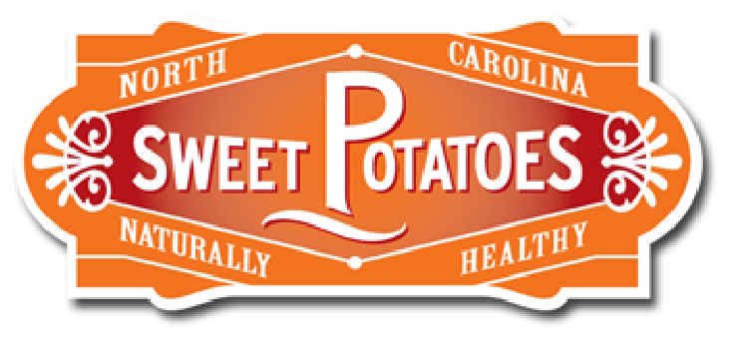
Sweetpotatoes: Culinary Trends and Applications

Grade Level(s):  9 – 12 |  | Lesson Description:  How are sweetpotatoes used in restaurants? The lesson will answer this question and explore how sweetpotatoes can be leveraged with today’s top flavor and menu trends. | Timeframe:  Minutes: 180  Suggested days: 2
Goals & Objectives  - Students will learn about trends within sweetpotatoes in the local culinary industry. |  |  | Prepared By:  Erica Hoskins  Family & Consumer Sciences Teacher  Apex High School  Wake County Public School System
North Carolina Family & Consumer Sciences Education Standards:
FH13 Culinary Arts and Hospitality III
1.02 Understand menu planning and nutrition
2.01 Remember cooking techniques.

Family & Consumer Sciences National Standards 3.0
8.4.2 Apply menu-planning principles to develop and modify menus
8.5.6 Prepare various stocks, soups, and sauces using safe handling and professional preparation techniques.
8.5.13 Integrate sustainability in food production and services including menu planning; acquisition, preparation, and serving of food; storage; and recycling and waste management.
8.5.14 Demonstrate cooking methods that increase nutritional value, lower calorie and fat content, and utilize herbs and spices to enhance flavor.
Materials Needed | - Laptops or iPads with stations PowerPoint loaded  - Station packet per group or student  - Ingredients for attached recipe

Anticipatory Set  10 Minutes | Write the following set of bell ringer questions on the board. Allow students 5 minutes to gather their thoughts and have volunteers share their answers.  Students should answer the following questions:  When do you serve sweetpotatoes?  What are your family traditions with sweetpotatoes?  Do you only eat sweetpotatoes at holidays?  What are some unique ways that you prepare sweetpotatoes?
Stations  80 Minutes | Split students into 4 groups. Students will rotate between the 4 stations. Below is an overview of each station students will visit. Use the PowerPoint slides at each station.  Station 1: Students will read two articles on current culinary trends of sweetpotatoes. Students will answer an article analysis for each of the two articles.  Station 2: Students will listen to a podcast from a local celebrity chef and answer questions about sweetpotato traditions and current restaurant trends with sweetpotatoes in NC.  Station 3: Students will change popular menu items to meet dietary needs and feature sweetpotatoes.  Station 4: Students will use the FCCLA Time Management Plan to prepare for lab the next day with a sweetpotato recipe that could be found in an upscale restaurant. | 4 iPads or Laptops  Station Packets
Lab  80 Minutes | Students will use the FCCLA Time Management Plan that they created the previous day. Have students prepare the sweetpotato soup with miso foam recipe. This recipe can be adapted to meet dietary needs (GF, V). | FCCLA Time Management Plan  Ingredients from attached recipe.
Summary/Evaluation  10 Minutes | Write the following question on the board. Allow students to think, pair, share. Have students turn in their answer for an exit slip grade.  How did these two days change your opinion of sweetpotatoes? Explain.
Source/Other Resources | (n.d.). Retrieved from http://fcclainc.org/programs/resources.php  Family affair: For Vivian Howard sweetpotatoes are a point of pride. (n.d.). Retrieved from https://www.splendidtable.org/story/family-affair-for-vivian-howard-sweet-potatoes-are-a-point-of-pride  Reiley, L., & Dam, A. V. (2019, April 20). Sweet corn out, sweetpotatoes in: Data shows fundamental shifts in American farming. Retrieved from https://www.washingtonpost.com/business/2019/04/20/sweet-corn-out-sweet-potatoes-data-shows-fundamental-shifts-american-farming/?noredirect=on&utm_term=.45293af61238  Sweetpotatoes. (n.d.). Retrieved from https://www.npr.org/tags/158870691/sweet-potatoes

Sweetpotato Stations: Culinary Trends

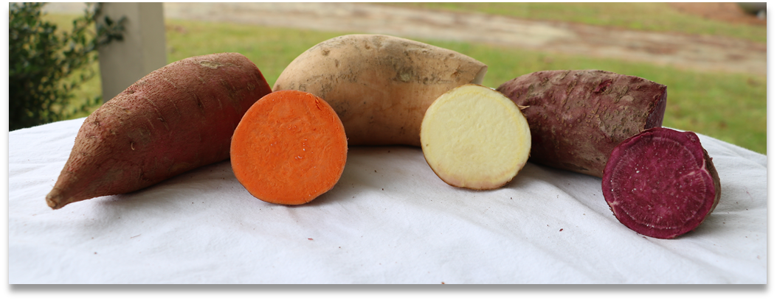

Station Packet

Name:________________________
Period:________________________
Date:________________
Station 1: Article Analysis

Read the two articles below about sweetpotato trends. Answer the questions for the article analysis. Discuss your answers with your group.

- https://www.npr.org/tags/158870691/sweet-potatoes
- https://www.washingtonpost.com/business/2019/04/20/sweet-corn-out-sweet-potatoes-data-shows-fundamental-shifts-american-farming/?noredirect=on&utm_term=.b825f30d47ac

Article 1:

Summarize the article:

What is the most important point in the article?

What do you predict will happen in the future?

Article 2:

Summarize the article:

What is the most important point in the article?

What do you predict will happen in the future?

Station 2: Podcast

- What does Vivian Howard do for a living?

- Where does she live?

- What local ingredients do people from this region eat?

- What is the difference between a yam and a sweetpotato?

- What is the most common variety of a sweetpotato?

- What are the memories of sweetpotatoes in her house growing up?

- What are some ways that the chef makes sweetpotatoes at her house?

- What do sweetpotatoes do to soups?

- What are some unique ways that Vivian Howard prepares sweetpotatoes?

- How does your group use sweetpotatoes in their cooking?
Station 3: Menu Descriptions

Research 5 popular recipes from restaurants of your choice and substitute ingredients to include a tasty vegan and gluten-free dish that features sweetpotatoes. Rewrite the menu description to “sell” these new dishes.

- Original Menu Item: ____________________________________

New Menu Item with Description: ________________________________________________________________________________________________________________________________________________________________________________________________________________________________________

- Original Menu Item: ____________________________________

New Menu Item with Description: ________________________________________________________________________________________________________________________________________________________________________________________________________________________________________

- Original Menu Item: ____________________________________

New Menu Item with Description: ________________________________________________________________________________________________________________________________________________________________________________________________________________________________________

- Original Menu Item: ____________________________________

New Menu Item with Description: ________________________________________________________________________________________________________________________________________________________________________________________________________________________________________

- Original Menu Item: ____________________________________

New Menu Item with Description: ________________________________________________________________________________________________________________________________________________________________________________________________________________________________________

Wrap Up Questions to Answer with Group:

- Would you try these recipes? Why or why not?

- Was this a difficult task? Why or why not?

- What are some benefits to adding special diets to your menu?

Station 4: Time Management Plan

Sweetpotato Soup with Miso Foam
Serves: 4 Servngs

INGREDIENTS
• 1 lb Sweetpotatoes
• 3 Shallots
• 2 tbsp Butter
• 2 cups Broth
• 3 apricots
• 1 cup Milk – you can also take almond or cashew milk
• 1 cup Cream – vegan cream alternative e.g. from oats
• 1 lime – peel and 1 tbsp lime juice
• 3 tbsp miso – gluten-free variant is with rice and not with wheat
• 1/2 tsp Tamari or soy sauce
• 1/2 cup of whole milk
• 1/3 cup of cream

INSTRUCTIONS
Soup:
1. Remove the peel of shallots and cut into small cubes.
2. Peel the sweetpotatoes and cut into small cubes.
3. Lightly heat the butter in a larger saucepan, sauté the shallots golden, add the sweetpotatoes.
4. Lightly sweat sweetpotatoes and pour on broth.
5. Cut the apricots into small pieces and place in the pot.
6. Simmer gently for about 20-30 minutes.
7. Add the cream, milk, lime peel and juice, simmer again for about 5-10 minutes.
8. Puree the soup with a blender.
9. Season with salt and pepper.

Foam:
1. Heat the milk, cream, miso and tamari lightly in a saucepan. It should not be too hot.
2. Using a whisk dissolve the Miso in the liquid well.
3. Mix the miso-milk-cream liquid with a blender to dress up to a light foam.

Serve the Sweetpotato Soup with some Miso Foam on top.

http://www.juleshappyhealthylife.com/en/sweet-potato-soup-with-miso-foam/

