Summary Evaluation and Images
These images and captions are correctly matched in this table.
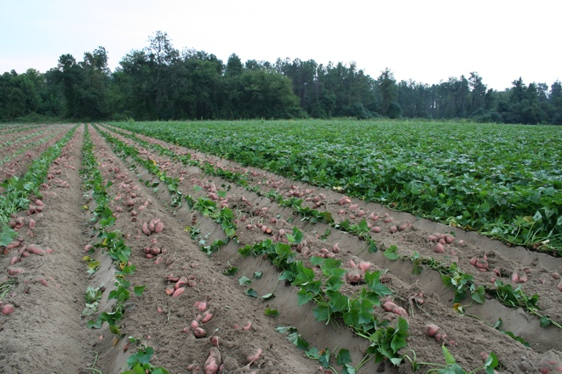 | 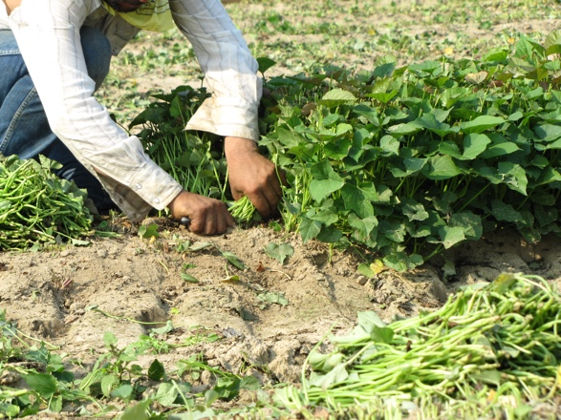 | 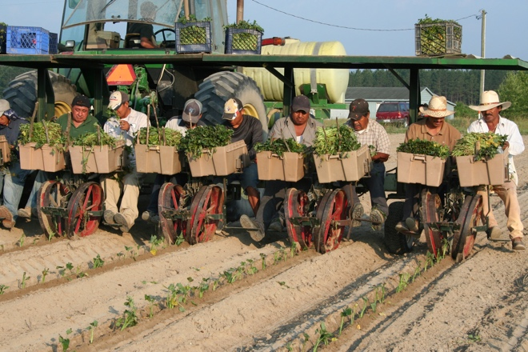
Sweetpotatoes are native to NC and grow well in the sandy soils. The sweetpotato’s root is a storage structure full of water, sugar, and nutrients. | Sweetpotatoes are started from cuttings known as slips or bedding seed potatoes. This can be done in a greenhouse or in the field. | Sweetpotatoes slips are transplanted in May or June.
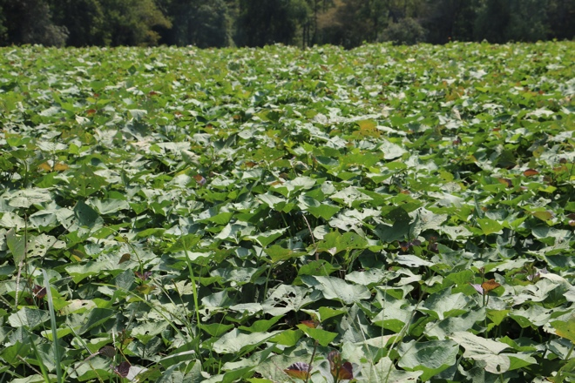 | 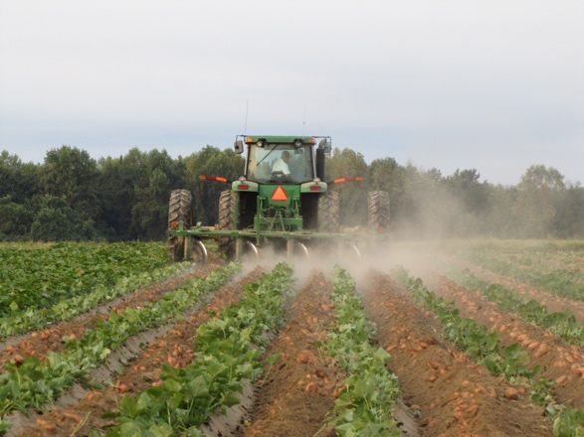 | 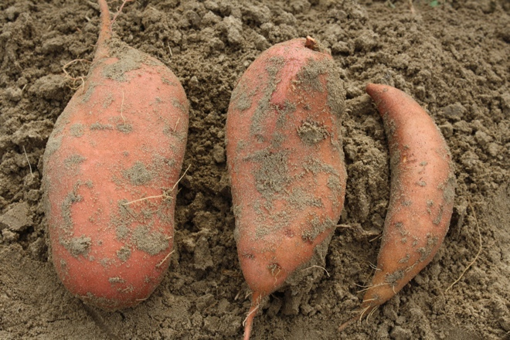
Sweetpotatoes are cultivated for 90-120 frost-free days in the field. | Sweetpotato roots grow in the ground and are dug usually in August. | Sweetpotatoes are machine harvested but sorted by hand. The smallest sweetpotatoes are called canners and the largest are jumbos.
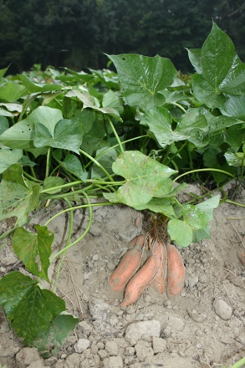 | 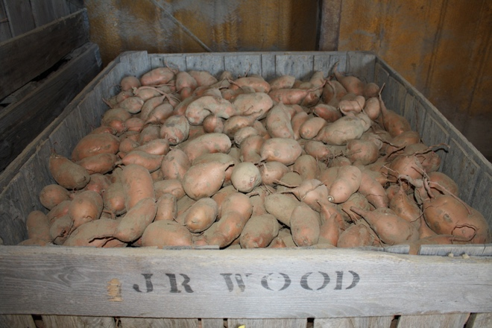 | 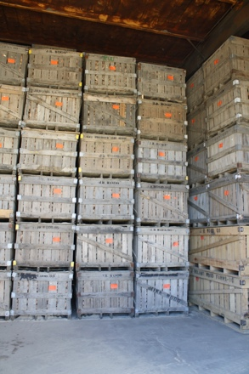
Sweetpotatoes that are dug and not cured are called “green.” These green sweetpotatoes can be easily injured. | Sweetpotatoes are cured. This is when the sweetpotatoes starches convert to sugar during 4-7 days of warm temperatures and high humidity. | Sweetpotatoes can be stored for up to one year in the proper facilities.
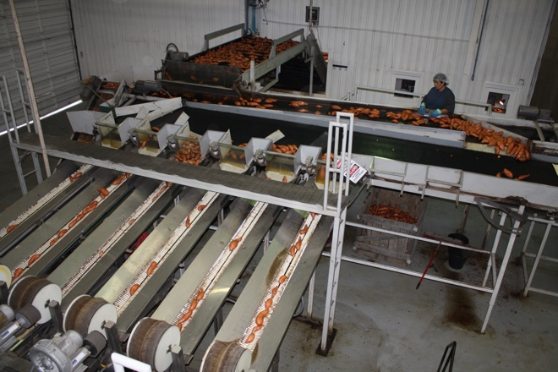
Sweetpotatoes are washed, sorted, and packed before going to market. | NC sweetpotatoes are shipped all around the world throughout the year.

