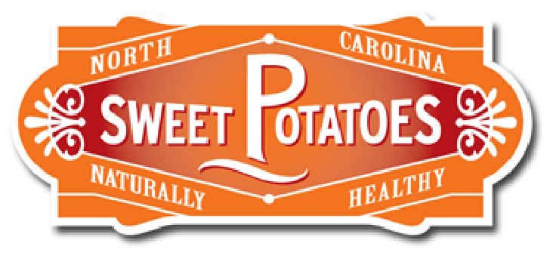
From Farm to Fork:

The Sweetpotato Food System

Grade Level(s):  9-12 |  | Lesson Description:  Using the sweetpotato as a model, students will explore the various steps in the food system from food production to resource and waste recovery. |  | Timeframe:  Minutes: 230  Suggested days: 2.5 - 3
Goals & Objectives  Students will…  - Understand and exemplify the steps of the food system.  - Develop a product concept that progresses through each step of the food system. |  |  |  | Prepared By:  Leigh Anne Church  Family & Consumer Sciences Teacher  Asheboro High School  Asheboro City Schools
North Carolina Family & Consumer Sciences Education Standards:
FN42 Food and Nutrition II  3.01 Understand food systems and local food. |  |  | FN43 Food Science and Technology  7.01 Understand “farm to table” as related to food production.
Materials Needed | - 1 raw sweetpotato  - Variety of sweetpotato products sold in stores  - From Farm to Fork Presentation  - Teacher computer and projector  - From Farm to Fork Graphic Organizer (1 copy per student)  - SweetPotato Product Development assignment and rubric (1 copy per group)  - Student computer and Internet access  - Online graphic design tools (optional)  - Market Order and Equipment Form (1 copy per group)  - Food supplies and kitchen equipment  - Food System Matching Game (1 copy per student OR 1 copy per group)

Anticipatory Set  15+ Minutes  What is “farm to fork”? Introduction | Teacher will display a variety of sweetpotato products sold in grocery stores in front of the class. Examples might include a frozen bag of sweetpotato fries, a can of sweetpotato puree, a pre-made sweetpotato pie, a box of sweetpotato pancake mix. Along with these products, teacher should include a raw sweetpotato. Teacher will lead the class in discussion, including the following questions:  - How do we go from this (sweetpotato) to this (sweetpotato products)?  - Have you heard the phrase “farm to table” or “farm to fork”? What does that mean?  - What is a food system?  Students will then pair up with a partner and jot down responses to the question:  - If we think about the sweetpotato’s journey from “farm to fork”, what are the various stops along the way?  After partners have discussed, students will share their answers with the class, while teacher records on the board.  If time and budget permits, teacher may choose to prepare some or all of the purchased sweetpotato products as a demonstration. Teacher may facilitate a taste test to sample various processed sweetpotato products available on the market. | 1 raw sweetpotato  Variety of sweetpotato products sold in grocery stores
Activity 1  20 Minutes  From Farm to Fork Presentation | Teacher will introduce the stages of the food system by presenting “From Farm to Fork: The SweetPotato Food System”. From Farm to Fork Presentation guides students through the seven steps of the food system by using the sweetpotato as a reference point. Students will take notes summarizing each step using From Farm to Fork Graphic Organizer. | From Farm to Fork Presentation  Computer and projector  From Farm to Fork Graphic Organizer
Activity 2  90 Minutes  SweetPotato Product Development | Working in groups, students will develop a sweetpotato food product of their own. Teacher will distribute SweetPotato Product Development assignment and rubric to groups. Students will work collaboratively through the seven steps of the food system by conducting research and answering questions that will refine their product concept. Internet access is needed for portions of this project, and students may choose to develop their logos using online graphic design tools. Students will select and alter a recipe for their product that will be prepared for the class to sample. | SweetPotato Product Development assignment and rubric  Student computer and Internet access  Online graphic design tools (optional)
Activity 3  90 Minutes  SweetPotato Product Lab and Presentation | Teacher will facilitate a lab experience for students to prepare the recipes they selected and altered during SweetPotato Product Development. Lab groups will complete a Market Order and Equipment Form before preparing their dish. Lab groups should present their completed dishes to the class and allow groups to sample the finished products.  If time permits, teacher may choose to have students present their finished products more formally with a display/presentation that demonstrates the development process. | Market Order and Equipment Form  Recipes from SweetPotato Product Development  Food supplies and kitchen equipment
Summary/Evaluation  25 Minutes  Food System Matching Game | As a review, students will play Food System Matching Game. Students can play individually, in partners, or in groups. Teacher should cut cards into sets of 21 before giving to students. Students will locate the seven steps of the food system, then match two examples of that step with each heading. Teacher should use an uncut card set as a key for this activity. After students have matched their cards, teacher will review correct answers with the class. | Food System Matching Game
Source/Other Resources | Alford, Z., Bloom, D., Conley, D., Blake, F., Simmons-Josilevich, J., Turner, K., . . . Helton, J. (2016, January 15). Gleaned  SweetPotatoes: Storage, Recipes, and Quick Facts. Retrieved May 18, 2019, from https://content.ces.ncsu.edu/gleaned-  sweetpotatoes-storage-recipes-and-quick-facts  North Carolina SweetPotato Commission. (n.d.). Growers. Retrieved May 18, 2019, from https://ncsweetpotatoes.com/sweet-  potato-industry/growers/  North Carolina SweetPotato Commission. (n.d.). Packers and Shippers. Retrieved May 18, 2019, from  https://ncsweetpotatoes.com/sweet-potato-industry/packers-and-shippers/

