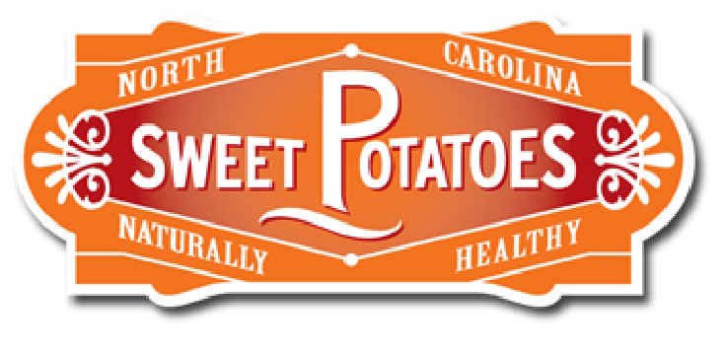
Appendix E
Sweetpotatoes WebQuest
Directions: Using the following website address link to the webpage for the North Carolina SweetPotato Commission: www.ncsweetpotatoes.com
Search through the website to find the answers to these questions.
- What is the difference between a yam and a sweetpotato?
--------------------------------------------------------------------------------------------------
_____________________________________________________________

- Explain how your store sweetpotatoes?

- List the 4 types of sweetpotatoes

- What are the different ways to cut a sweetpotato?

- What are 3 benefits of eating a sweetpotato?

- How many calories are in 1 medium sweetpotato? _________________

- What state is the number one in sweetpotato production? __________

- True or False? Sweetpotatoes are too sweet for diabetics. __________

- About how many growers make up the NC SweetPotato Commission? ________

- True or False? Sweetpotatoes should be stored in the refrigerator to avoid decay

- Review the website and write down 3 things you learn about NC Sweetpotatoes.

*
*
*

