Appendix B
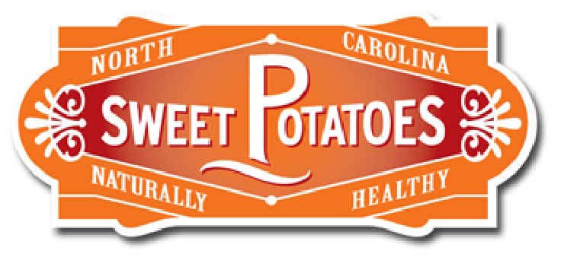
Sweetpotato Note Taking Facts
What is the different between yam and a sweetpotato? Explain 3 things you learned. https://ncsweetpotatoes.com/sweet-potatoes-101/difference-between-yam-and-sweet-potato/
1.____________________________________________________________________________________
_____________________________________________________________________________________
2.____________________________________________________________________________________
_____________________________________________________________________________________
3.____________________________________________________________________________________
_____________________________________________________________________________________
Explain 3 things you learned from taking the Pop Quiz: Sweetpotato VS Yam
https://ncsweetpotatoes.com/pop-quiz-sweet-potato-or-yam/
1.____________________________________________________________________________________
_____________________________________________________________________________________
2.____________________________________________________________________________________
_____________________________________________________________________________________
3.____________________________________________________________________________________
_____________________________________________________________________________________

