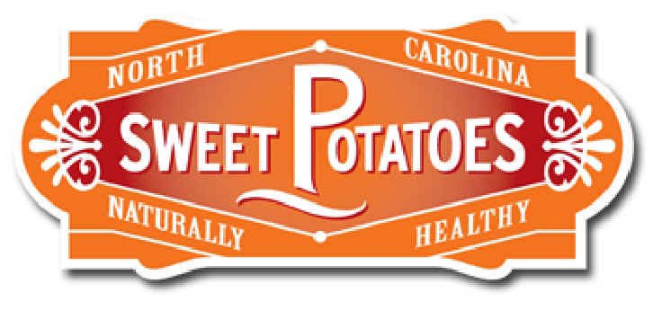
Presenting Our Sweet Poster!

Sweetpotato Lesson - MS

Day 3

Grade Level(s):  6th – 8th grade |  | Lesson Description:  Students learn about the nutritional benefits of sweetpotatoes |  | Timeframe:  Minutes: 45 min (DAY 3)  Suggested days: 3 days to implement full PBL project
Goals & Objectives  This middle school lesson will introduce students the nutrition of sweetpotatoes.  - Students will be able to  - Identify the differences between potatoes & sweetpotatoes  - Explain the different between a yam and sweetpotato  - List the 3 types of sweetpotatoes  - Explain the 5 nutritional benefits of sweetpotatoes  - Explain why sweetpotatoes are a healthy choice for a diabetic  - Explain why sweetpotatoes part everyone’s diet should be especially those seeking to be healthier and fitter |  |  |  | Prepared By:  Barnanne Creech  Family & Consumer Sciences Teacher  Zebulon GT Magnet Middle School  Wake County Public Schools
North Carolina Family & Consumer Sciences Education Standards:
3.01 Understand the impact of choices on wellness  1. What is the current USDA issued food guide and dietary guidelines?  2. What are the 6 essential nutrients?  3. What is a food label and how can you read and understand a food label/ingredient lists? |  |  | Day 2  Essential questions  1.Which of the 6 essential nutrients that a sweetpotato provides does a person with diabetes may worry about?

Family & Consumer Sciences National Standards 3.0
http://www.nasafacs.org/national-standards-and-competencies.html
9.4 Apply basic concepts of nutrition and nutrition therapy in a variety of settings, considering social, geographical, cultural and global influences.
9.4.5 Design instruction on nutrition to promote wellness and disease prevention

Materials Needed | *laptop  *LCD  *poster paper  * markers

Anticipatory Set  5 Minutes | Teacher asks,  “Which of the 6 essential nutrients that a sweetpotato provides does a person with diabetes worry about?  6 essential nutrients are : Proteins, Fats, Carbs, Vitamins, Minerals & Water  Answer: Carbohydrates (which break down to glucose)  Teacher shows website and discusses  https://ncsweetpotatoes.com/usda-sweet-potato-nutritional-analysis/diabetes-friendly/  Can diabetics eat sweetpotatoes? Absolutely!  There is a great deal of confusion about whether or not people with diabetes can include sweetpotatoes in their diet. Before including any foods in to your diabetic eating plan, consult your healthcare professional.  Plus, sweetpotatoes contain virtually no fat and are low in calories. A medium baked sweetpotato eaten with the skin is a mere 103 calories, about the same as half a cup of brown rice.  And there might be even more reason for diabetics to include sweetpotatoes into their eating plans. Research has found these root veggies may play a role in stabilizing or lowering blood sugar, due to their low glycemic index. Foods low on the glycemic index break down more slowly in the body, which may produce fewer fluctuations in blood glucose and insulin levels (source). | *Laptop  *LCD Player
Activity 1  25 Minutes  Groups of 2 | Our Sweet Poster! Completion  Students get back with their teammate and finish the poster they began on day 2  Using the new knowledge student teams are to finalize  - poster informing the viewer of nutritional benefits of sweetpotato  Review Rubric and then give students time to finalize poster  Remind students the following should be included in their poster  - Explain the 5 nutritional benefits of sweetpotatoes  - Explain why sweetpotatoes are a healthy choice for a diabetic  - Explain why sweetpotatoes part everyone’s diet should be especially those seeking to be healthier and fitter | *5, 4, 3, 2, 1 Reading Reflection (Appendix C)  *PBL Rubric (Appendix D)  Posters can be completed  *by hand  *on the computer
Activity 2  10 Minutes | Our Sweet Poster! Presentations  Option 1  Students teams will present their posters to the class.  Option 2  Completed posters are hung on the classroom wall and student complete a gallery walk viewing the completed posters.
OPTIONAL  Extension Activity  Activity 3 | If teams finish their poster ahead of the 25-minute allotted timeframe.  As student teams finish have them complete WebQuest of the https://ncsweetpotatoes.com/ | Optional Sweetpotato WebQuest  Appendix E
Summary/Evaluation  5 min | Students should each share one thing they have learned about the nutritional benefits of eating sweetpotatoes.
Source/Other Resources | (n.d.). Retrieved from https://ndb.nal.usda.gov/ndb/foods/show/11507  Sweetpotato Benefits. (n.d.). Retrieved from https://ncsweetpotatoes.com/usda-sweet-potato-nutritional-analysis/benefits-of-sweet-potato/  Sweetpotatoes Keep You Moving. (n.d.). Retrieved from https://ncsweetpotatoes.com/sweet-potatoes-and-fitness/

