Appendix A
Potato Matching Game
Copy on a color printer and cut for game.

SWEETPOTATOES: I can be long and thin or short and fat but always taper at the end. I am part of the red/orange group in the MyPlate vegetable group. I have lots of vitamin A and vitamin C.

RED POTATOES: These small to medium, round or slightly oblong potatoes have a smooth red skin and white flesh. My skins are loaded with fiber, B vitamins, iron and potassium.

FINGERLING POTATOES: These potatoes are two to three inches long and as their name suggests, are finger shaped. Their skin comes in red, orange, purple and white. I am an excellent source of potassium-I have more than a banana.

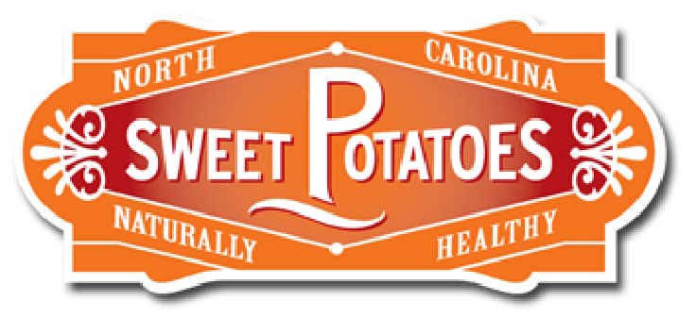

RUSSET POTATOES: I am large with dark brown skin and few eyes. I am popular baked and many restaurants use me for french fries. I am an excellent source of vitamin C, B6, magnesium, fiber, and also contain some iron.

WHITE POTATOES: I get my name from the white coloring of my skin and flesh. I am perfect for mashing. I am also used in salads and am perfect for steaming, boiling and frying.

