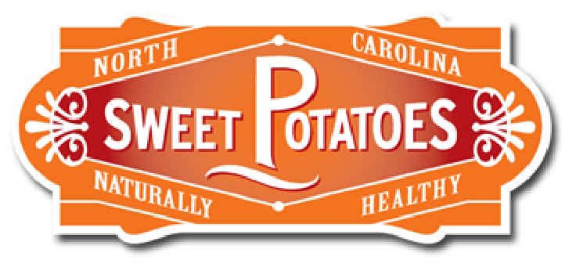
Who’s Got an Orange Thumb?

Sweetpotato Lesson - MS

Growing a Sweetpotato - Day 1

Grade Level(s):  6th – 8th grade |  | Lesson Description:  Students learn how to explore the biology of sweetpotatoes |  | Timeframe:  Minutes: 45 min  Suggested days: 2 days with weekly follow ups on growth
Goals & Objectives  This middle school lesson will incorporate botany, horticulture, and general biology, into the Family and Consumer Sciences classroom and facilitate a planting/growing project.  Students will be able to:  *explain how a sweetpotato grows  *grow a sweetpotato slip |  |  |  | Prepared By:  Barnanne Creech  Family & Consumer Sciences Teacher  Zebulon GT Magnet Middle School  Wake County Public Schools
North Carolina Family & Consumer Sciences Education Standards:
Module 3-Nutrition and Wellness
ES 3.00 Understand factors that influence nutrition and wellness.
3.01 Understand the impact of choices on wellness.
3.02 Understand kitchen basics.
3.03 Understand nutritious meal planning and preparation.

Family & Consumer Sciences National Standards
http://www.nasafacs.org/national-standards-and-competencies.html
14.4 Evaluate factors that affect food safety from production through consumption. | 14.5 Evaluate the influence of science and technology on food, nutrition, and wellness.

Materials Needed | *laptop  *LCD  *student handouts  *paper  *markers  *document camera  *materials to grow a sweetpotato on day 2 – cup, water, sweetpotato, toothpicks

Anticipatory Set  15 Minutes | Teacher holds up a sweetpotato and asks “does anyone know how to grow a  Sweetpotato?”  Pass out 3, 2, 1 handout  Show student video “Making It Grow - Sweetpotato Research”  https://www.youtube.com/watch?v=gE1EO-ONko4  Students record using the 3,2,1 handout  Debrief after the video, as to what they wrote on their handouts | *Computer  *LCD  *Sweetpotato  *3, 2, 1 handout Appendix A
Activity 1  20 Minutes | Students get into groups of 2  Students get laptops – 1 laptop per team  Students are to read “From Farm to School Crops of NC – Digging for Sweetpotatoes” PDF Link in the folder  Student read to each other and  t  hey individually complete the Summarizing Handout – Appendix B | *Lap tops  *Summarizing handout – Appendix B
Activity 2  5 minutes | Talk with partner about what the 3 supporting details an overall summary from reading the book. Students review what they wrote on the summarizing handout.
Activity 3  3 Minutes | Prep for students to next class lesson as they will create 3 Summary paper slides about what they read in the book.
Summary/Evaluation  2 min | Exit ticket time! Using complete sentences, each student write down 1 thing they learned today from the lesson. Share their exit tickets with one another.
Source/Other Resources | “Industry.” North Carolina Sweetpotatoes, ncsweetpotatoes.com/sweet-potato-industry/  SouthCarolinaETV. “Making It Grow - Sweetpotato Research.” YouTube, YouTube, 22 Feb. 2017, www.youtube.com/watch?v=gE1EO-ONko4.

