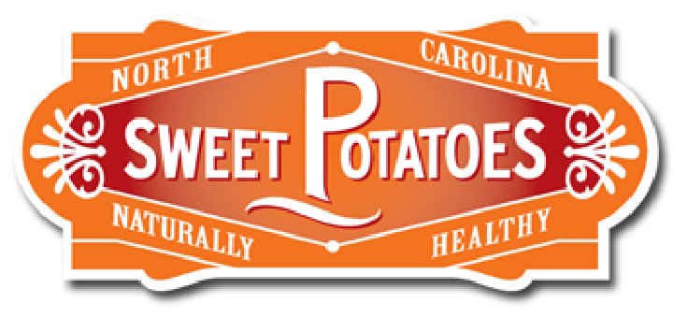
Sweet Poster!

Sweetp otato Lesson - MS

Day 2

Grade Level(s):  6th – 8th grade |  | Lesson Description:  Students learn about the nutritional benefits of sweetpotatoes |  | Timeframe:  Minutes: 45 min (DAY 2)  Suggested days: 3 days to implement full PBL project
Goals & Objectives  This middle school lesson will introduce students the nutrition of sweetpotatoes.  - Students will be able to  - Identify the differences between potatoes & sweetpotatoes  - Explain the different between a yam and sweetpotato  - List the 3 types of sweetpotatoes  - Explain the 5 nutritional benefits of sweetpotatoes  - Explain why sweetpotatoes are a healthy choice for a diabetic  - Explain why sweetpotatoes part everyone’s diet should be especially those seeking to be healthier and fitter |  |  |  | Prepared By:  Barnanne Creech  Family & Consumer Sciences Teacher  Zebulon GT Magnet Middle School  Wake County Public Schools
North Carolina Family & Consumer Sciences Education Standards:
3.01 Understand the impact of choices on wellness  1. What is the current USDA issued food guide and dietary guidelines?  2. What are the 6 essential nutrients?  3. What is a food label and how can you read and understand a food label/ingredient lists? |  |  | Day 2  Essential questions  1. Which of the 6 essential nutrients does a sweetpotato provide?  2. In reading a nutritional label for a sweetpotato which essential nutrients provided in a sweetpotato?

Family & Consumer Sciences National Standards 3.0
http://www.nasafacs.org/national-standards-and-competencies.html
9.4 Apply basic concepts of nutrition and nutrition therapy in a variety of settings, considering social, geographical, cultural and global influences.
9.4.5 Design instruction on nutrition to promote wellness and disease prevention

Materials Needed | *laptop  *LCD  *sweetpotato  *lap top (1 per student) or printed information for each student  *5, 4, 3, 2, 1 Reading Reflection (Appendix C)  *PBL Rubric (Appendix D)

Anticipatory Set  5 Minutes | Teacher asks,  “Remember our study of the 6 essential nutrients”  “What are the 6 essential nutrients?”  Carbs, Fats, Proteins, Vitamins, Minerals and Water  Teacher holds up a sweetpotato and asks  “how many of the 6 essential nutrients are in a sweetpotato?”  “what are the essential nutrients in a sweetpotato?”  Carbs, Proteins Vitamins, Minerals and Water  Teacher shows Nutritional Facts Label  https://ndb.nal.usda.gov/ndb/foods/show/11507  Reviews how to read the information on the nutritional facts label | *Laptop  *LCD Player
Activity 1  15 Minutes  Groups of 2 | Sweetpotato Jigsaw Activity  Scenario for PBL Activity  “You and your partner work for a marketing firm called “Go Big or Go Home Marketing Company” and have been hired by the NC Sweetpotato Commission to create a marketing poster/flyer that can posted on Snap Chat, Instagram and Facebook informing others about the nutritional importance of incorporating sweetpotatoes into ones daily diet.  The poster is to highlight the nutritional benefits of sweetpotatoes  To gain the information needed for this project;  One student will become an expert in the “Benefits of Sweetpotatoes”  https://ncsweetpotatoes.com/usda-sweet-potato-nutritional-analysis/benefits-of-sweet-potato/  and the other student will become the expert in “Sweetpotatoes and Fitness”  https://ncsweetpotatoes.com/sweet-potatoes-and-fitness/  To begin, you will read and record your learnings on the 5, 4, 3, 2, 1 reading reflection handout Appendix C) as you become an expert in your specific area. | *Laptops 1 per student  *5, 4, 3, 2, 1 Reading Reflection (Appendix C)  *PBL Rubric (Appendix D)  Classrooms with no computers for students to use to research print off the online page and give to students.
Activity 2  10 Minutes | Sweetpotato Expert Roundtable  Group all the ““Benefits of Sweetpotatoes” experts  Group all the “Sweetpotatoes and Fitness”  Students are to share their 5,4,3,2,1 reflection | *5, 4, 3, 2, 1 Reading Reflection (Appendix C) with  Expert round table thoughts
Activity 3  10 Minutes | Sweet Poster Activity – Day 1  Students get back into original expert pairs verbally share their expert knowledge with their teammate.  Using the new knowledge student teams are to create  - poster informing the viewer of nutritional benefits of sweetpotato  The poster must explain the following  - Explain the 5 nutritional benefits of sweetpotatoes  - Explain why sweetpotatoes are a healthy choice for a diabetic  - Explain why sweetpotatoes part everyone’s diet should be especially those seeking to be healthier and fitter  Review what the 3 points the poster must contain & review the rubric and then give students time to create.  As student teams finish have them complete scavenger hunt of the https://ncsweetpotatoes.com/ | Poster paper  Markers  Optional Sweetpotato Website Scavenger Hunt
Summary/Evaluation  5 min | Have student teams share the beginnings of their “Sweet Poster”  Have students put the posters in a holding area in the classroom as they will finish on day 3
Source/Other Resources | (n.d.). Retrieved from https://ndb.nal.usda.gov/ndb/foods/show/11507  Sweetpotato Benefits. (n.d.). Retrieved from https://ncsweetpotatoes.com/usda-sweet-potato-nutritional-analysis/benefits-of-sweet-potato/  Sweetpotatoes Keep You Moving. (n.d.). Retrieved from https://ncsweetpotatoes.com/sweet-potatoes-and-fitness/

