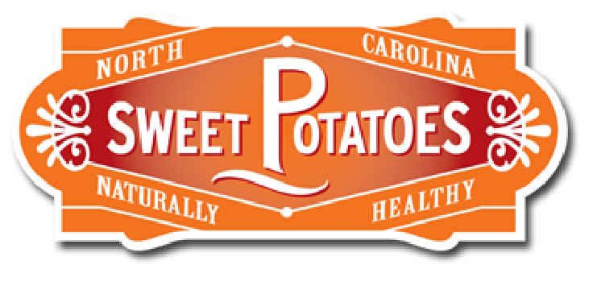
Sweetpotato – Healthy Snacks - Appendix A
Kitchen/Food Lab Duties

Head Chef
o Tied hair back, removed coat, put on apron and washed hands.
o Got all necessary food supplies from supply area (refrigerator or cabinet) and returned unused items.
o Put on gloves.
o Read the recipe/directions and followed them properly.
o Gave responsibilities to Sous Chef to help in the preparing of the recipe.
o Cleans counters and stove area with spray cleaner.

Sous (sue) Chef
o Tied hair back, removed coat, put on apron and washed hands.
o Got all the necessary kitchen tools to prepare the food.
o Put on gloves.
o Read the recipe and followed the directions properly, helping the head chef.
o Prepare plates/cups with the prepared food.
o Swept the floor in the kitchen and under the table were the food was served and eaten.

Class Host
o Tied hair back, removed coat, and washed hands.
o Put on gloves.
o Set the table. (tablecloth, placemat, napkin, cup and eating utensils when needed)
o Got plastic cups wrote on them team members names on them and placed them on table
o Made /poured the beverage. (Got pitcher, put water in pitcher, got 5 cubes of ice from freezer)
o Put condiments on table if needed on a paper plate. (olive oil, balsamic vinegar, ketchup)
o Helped the head chef or sous chef if asked.
o Helped the Kitchen Manger and dried the kitchen tools and put them on drying towels or in drying rack.
o Made sure that the food prep/kitchen and eating area were cleaned and ready to be used for next class.
o Cleared the table by putting pitcher back in drying rack, putting placemats and tablecloth back in proper place.

Kitchen Manager
o Tied hair back, removed coat, and washed hands, put on apron.
o Set up dishwater in sink. (hot/warm water with a few drops of dishwashing liquid in one sink)
o Got drying towels and wash cloth for their kitchen area.
o Washed and rinsed kitchen tool then handed to Class Host to dry and put on drying towels or in drying rack.
o At end of lab cleaned and dried out the sink.
o Made sure that the food prep/kitchen and eating area were cleaned and ready to be used for next class.

